

TITLE OF

PROJECT

**RESTAURANT**

END TERM REPORT

By

NAME OF THE CANDIDATES:

VIKAS KUMAR

(Reg Number: 11909519)

(Section: K19QW)



The Webpage is about a restaurant named as the “RESTAURANT”.The restaurant is situated in one of the main city of Punjab i.e. Jalandhar.The main motive of the restaurant is ‘to the people , for the people and by the people’.The people associated with the restaurants are fully committed towards their work.It has variety of options for all kind of customers and with special offers ,per day of the week.There is a very vast variety of food available in every section of the available food.As the location of the restaurant is highly visited by the tourists from all across the globe due to various reasons,it includes variety of food for the people of all region of the country as well as the people who are from abroad.The Restaurant assures you about the best quality of food to be served with the most affordable price for the customer.We strongly believe in our culture and follow it too which says ‘Athiti Devo Bhava’.

**HOME-**The first icon is of the HOME which will redirect the user from any page of the website to the first page of the website or the home page.This page will give a brief idea to the user about our page and our **RESTAURANT.**

**ABOUT**-The second icon is about the us and the whole staff of our restaurant which tells what is our main objective to work and what are the areas about which are concerned for the customers satisfaction.

**PRICING-**The third icon is about the cost or the price of each dish or drinks which are available in our restaurant.The Price is written very clearly in order to avoid any confusion for our customers.We assure you about the price and quality of the food that will be presented to you.We also hope that you will have a very good experience in our RESTAURANT.

**BREAD -**The third section is about the bread

and the things related to the bakery.Our baked products are famous across the whole city.The section also contains about the menu of the Breakfast.We offer you a very healthy and energetic Breakfast.

**FEATURED-**The fourth icon is about the special dishes that is being available to our customers every day of the week respectively.These are the special dishes which will be available to you on exclusive offers and discounts.This dishes are specially made for our customers in order to make them familiar with this regional dishes of our countryside.

**RESERVATION-**The fifth icon of the page is for the reservation or for the early booking of a particular table.As our restaurant has table placed at different places and each place having a very different view in itself,raises the curiosity of the customer in order to book the table as per their choice of view and location.

**CONTACT-** The last icon is of contact which is for the customers to call directly to our hotel and ask for any queries related to our restaurant.We will be very happy to help our customers in whichever possible way.

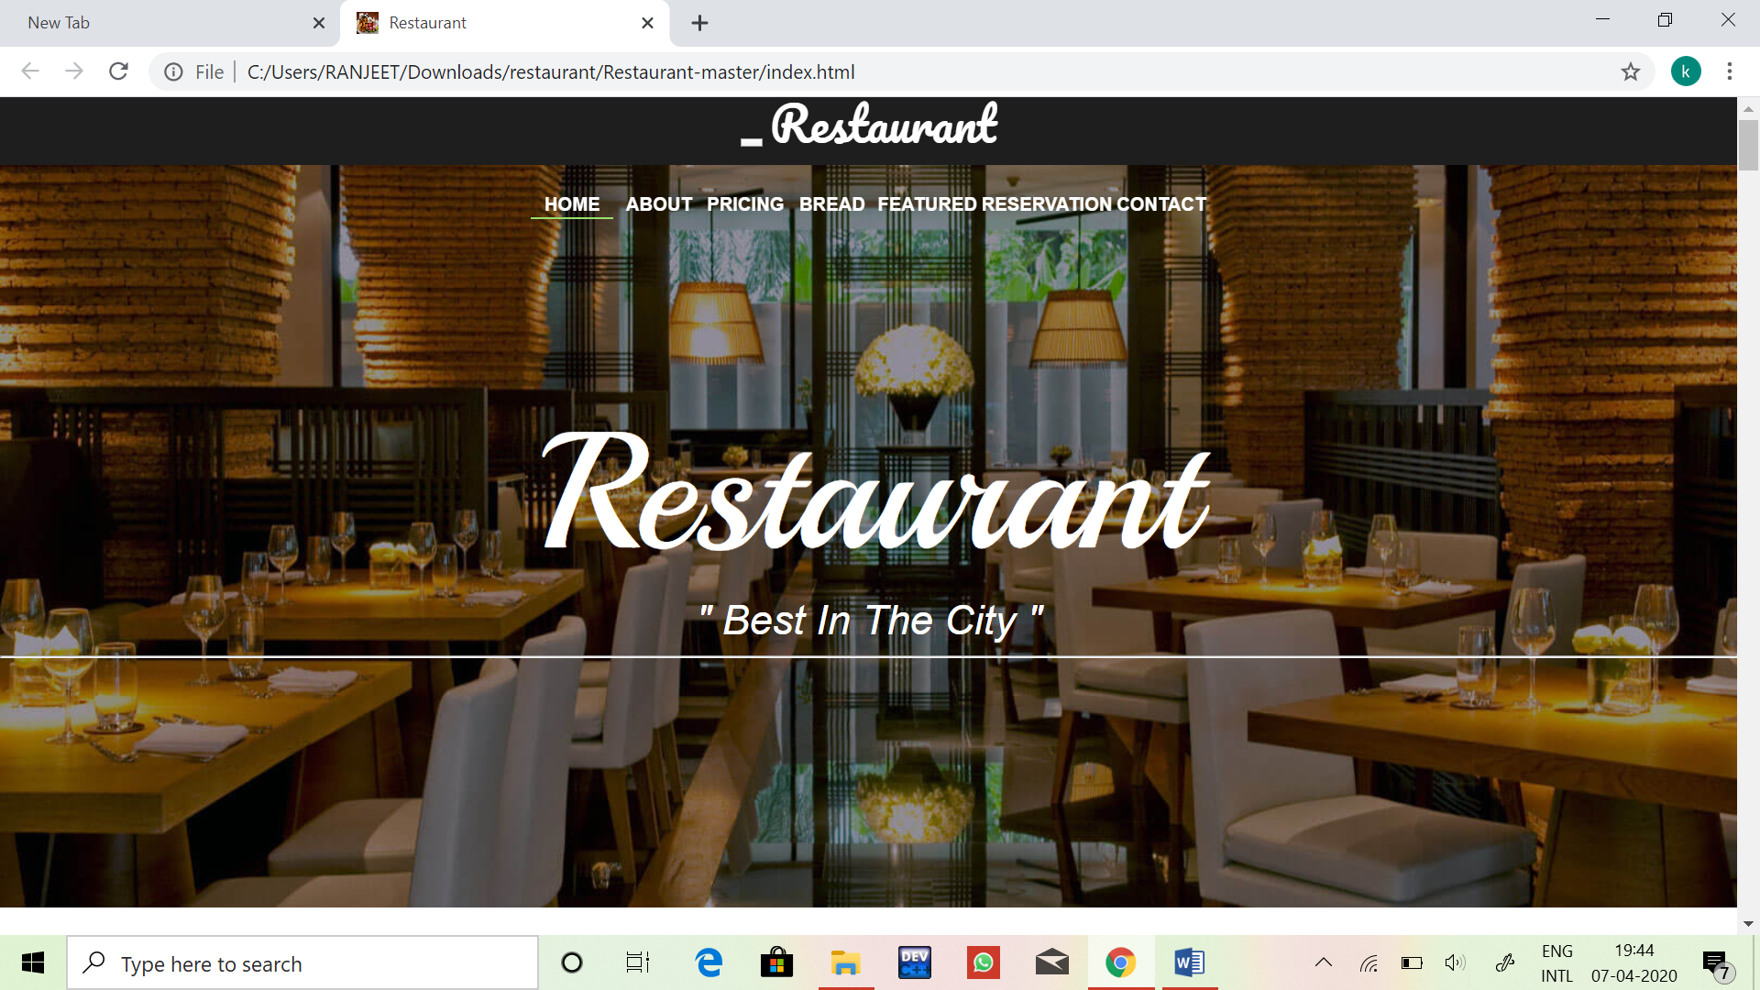

**CONCLUSION-**The webpage is all about a restaurant located in a city.The main of the webpage is to make people aware of our beautiful restaurant.It contains every information of our restaurant which will really help the customers.We also ask the visited customers to give us the online review on the site which may really helpful to gain the new customers for our restaurant.

**I am the alone member as the group partner who has been assigned with me is not studying in this University at present.**